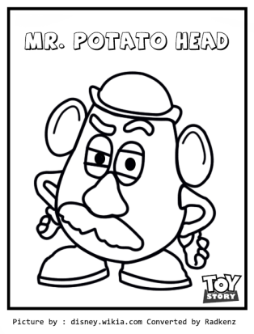
Be a Hot Potato at Brockett! Bring in your potato dressed like your favorite storybook character. This contest is OPTIONAL!
Potato Character Contest

**Examples can be found on Brockett webpage: brockett.mansfieldisd.org (and Pinterest)
- Buy a potato or potatoes at the grocery store this week.
- Decorate your potato like a character from a story. It can by a nursery rhyme, fairy tale, fiction book, or any book you like.
- Stand the potato up. You can cut the bottom of a Styrofoam cup or toilet paper roll.
- On your stand write the name of your character, your name, and your teacher’s name.
- Have fun and create your character!
- Bring your finished potato to the library on Tuesday, October 10th. Potatoes will be displayed through Friday, October 20th.
- The top three winners will receive a $10 gift certificate to the book fair held the following week.
- Potatoes MUST go home on Friday, October 20th or they will be discarded. (They will start to rot after a week.)

